Jira Assignment 3

**Screenshot 1** – add 2 people to your team/project (do not add more than 10 people or your account will become paid)

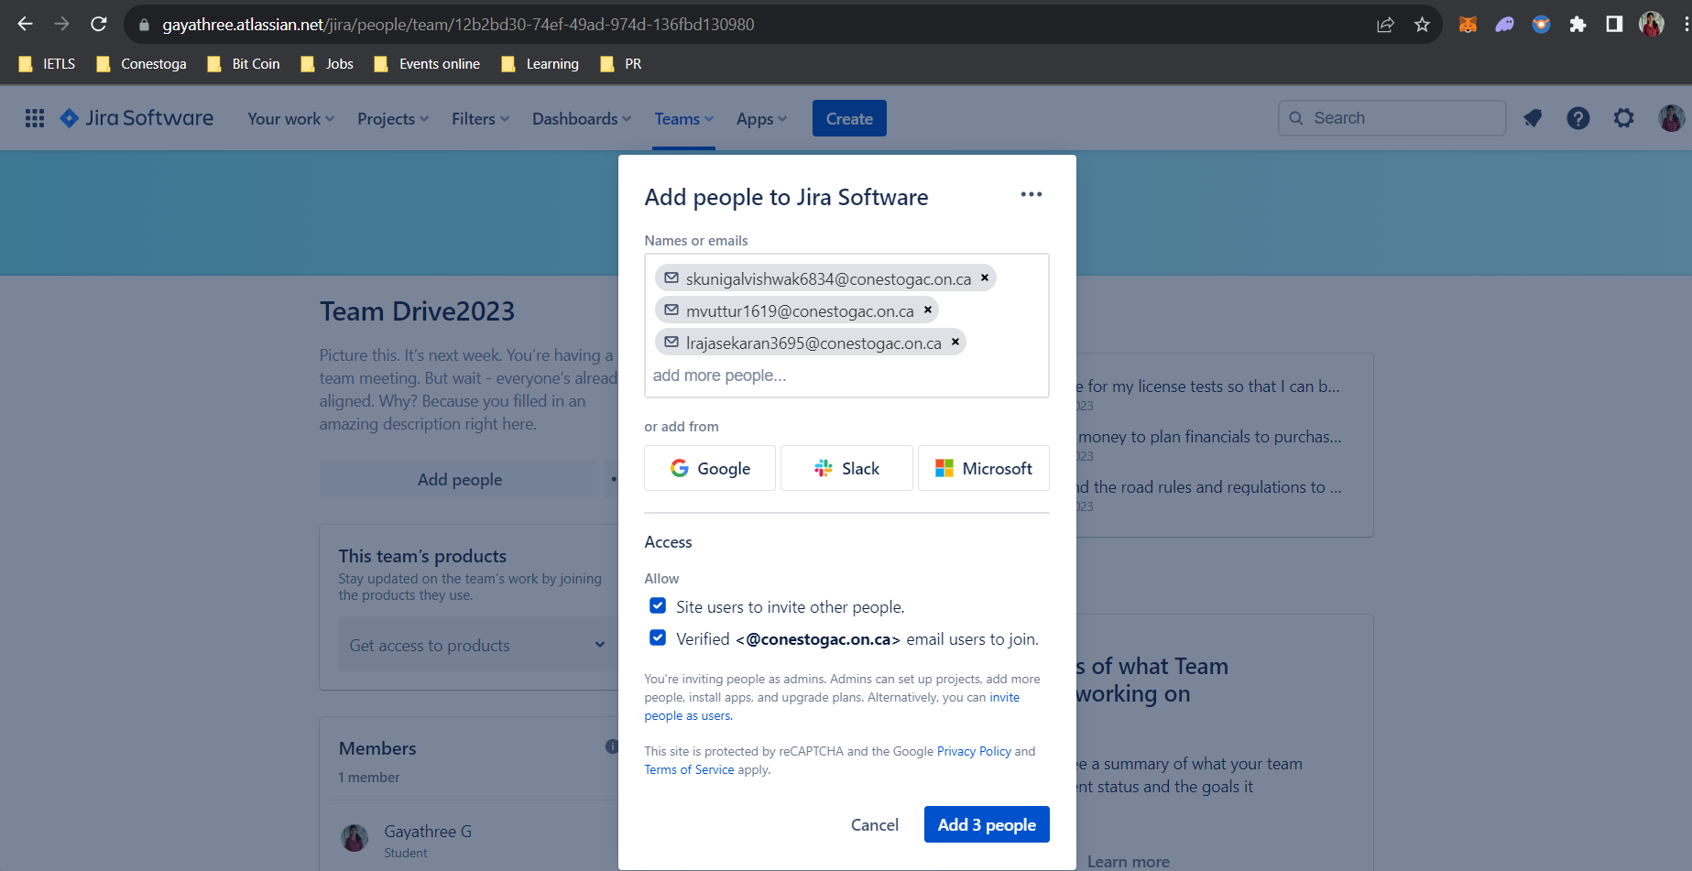

**Screenshot 2** – create a team and add team members

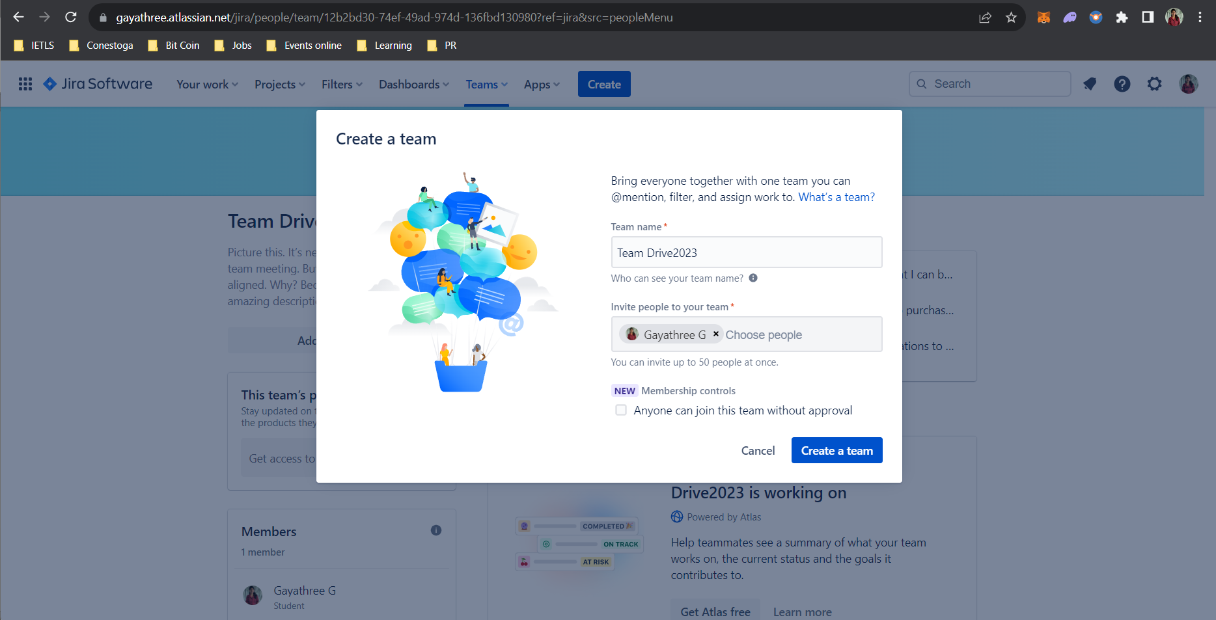

**Screenshot 3** – People page showing added users and team created

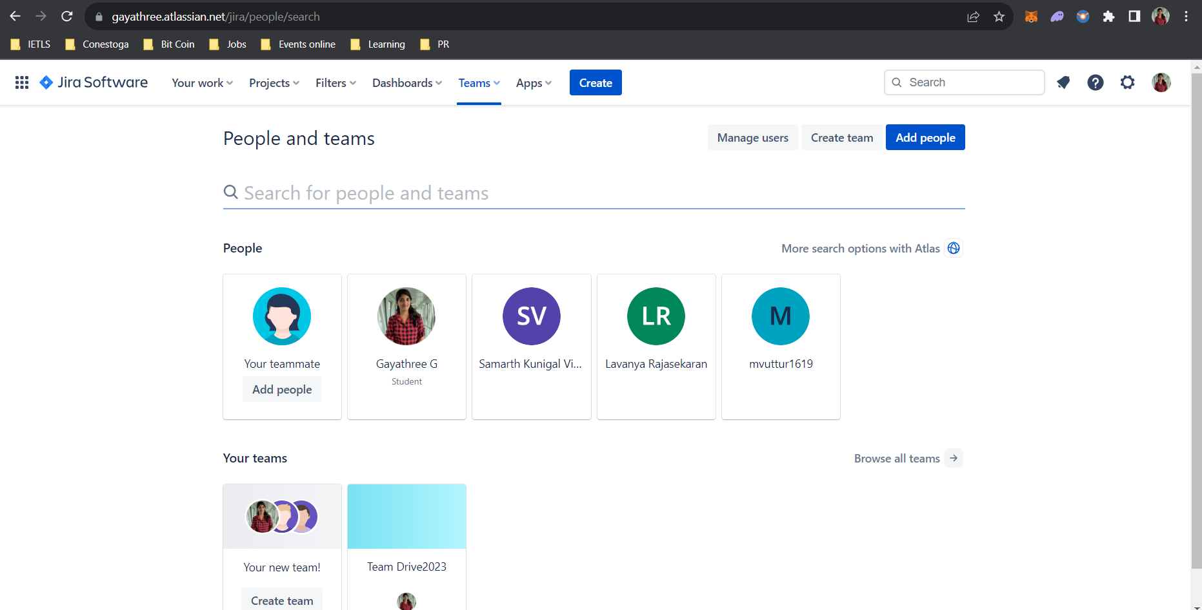

**Screenshot 4** – Rewrite your user stories properly

